*Transdisciplinary Case Study of Health and Physical Activity in Old Age*

**SENIORS IN MOTION –**

**Transdisciplinary Approaches to Physical Activity Promotion for Older People**

**Manual for instructors**

This Case Study was constructed within the tdAcademy project, which aims to build a transdisciplinary knowledge platform. Founding partners are the Frankfurt Institute for Social-Ecological Research, the Center for Technology and Society at Technische Universität Berlin, the Oeko-Institut in Freiburg and the Leuphana University Lüneburg.  
In this Case Study, participants will be encouraged to learn from sustainability issues and real-world transdisciplinary research in the field of health research.

**Educational Objectives**

Throughout this Case Study, participants should...

* Learn some **basics of transdisciplinary research** **and related methods** by applying them to a real-world context
* Gain first insights on **how to construct and conduct transdisciplinary research projects**
* Get to know their **competencies as a transdisciplinary researcher**
* Adopt the role of a **leading position** in a transdisciplinary research project
* **Work collaboratively** in a team, both practically and fictionally
* Find out about **new tools and methods for effective teamwork**

Their learnings will relate to topic lines of the tdAcademy, which investigate core questions of transdisciplinary research, such as:

1. The **societal effects** of transdisciplinary research,
2. The **scientific effects**of transdisciplinary research,
3. Dealing with **contextual dependencies**.

**About the Case Study**

The Case Study’s structure was adapted from the Harvard Business Case Studies, which have established themselves as valuable educational practice in the business context.

The participants’ main task will be to construct a fictitious transdisciplinary research project. The Case Study consists of three parts and will be worked on in groups. Before the participants start with the construction of their research projects, they will have time for getting to know each other and for general group organization. In order to simulate contextual dependencies, each group can choose different stakeholders, whom they will be constructing their project with. Each group will also have a different thematic focus and related challenges which show the diversity in research projects and potential scientific impacts.

Then, the participants will start working together on their main task. For constructing the fictitious research projects, the Case Description and the additional materials contain necessary information about the promotion of physical activity for older people.

As the third part, the participants’ groups will present their results to each other and reflect on their processes and learnings.

**Course Structure and Schedule**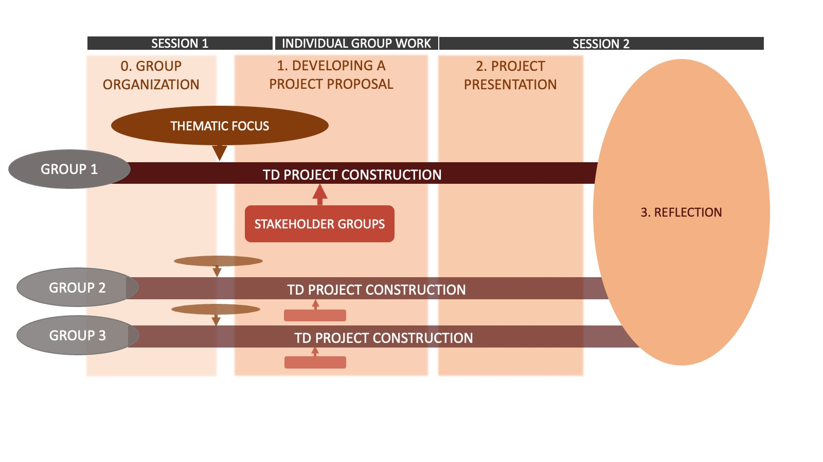

**Before** the course starts...

Please send an **e-mail** to all participants. A suggestion for such an e-mail is provided in the Case Study package. It should contain...

* Mandatory Readings: Case description & key transdisciplinary literature (to be read by the participants before the first session)
* Reflection task for participants: What are skills they have or topics they are interested in which could impact their own transdisciplinary research?

**During** the Course...

In the Case Study package, you are provided with two power point presentations containing all additional requirements – one for each session of the Case Study. **The outlined times for tasks and breaks below are suggestions.**

***Session 1 [3:30 h]***

* **Introduction [35 mins]**
  + Please *give an overview*of the Case Study (learning objectives, insights into the importance and positive effects of physical activity for older people, transdisciplinary research, structure) and the tasks ahead (Slide 1-7).
  + To establish a common knowledge base among the participants, briefly revisit the two publications on transdisciplinary research that were sent to the participants in advance (Slide 5). Let the participants gather the most important insights from the papers in the plenary. The fictious research projects the participants design should be based on the ideal-typical transdisciplinary research process by Lang et al. (2012) and can profit from the framework of Bammer (2019).
  + Let the participants know where the Powerpoint slides are uploaded. All material can be found in the slides and will be necessary for working on the tasks.
  + *Sort**all participants into groups of 4-5.*
* **Group Organization – Task 0** (Slide 8-12)
  + The different groups now have time to get to know each other and to organize themselves as a group. Exemplary pointers for this are given on Slide 11-12. As an instructor, you are free to *provide participants with further ideas and tools* for improved group organization, such as data sharing and communication tools **[25 mins]**.
* **Short Break [ca. 10 mins].**
* *Get back into the plenary, resolve questions or difficulties and present the next two tasks, that will be worked on in break-out rooms.* 
  + **Thematic Focus – Task 1A** (Slide 13-21): Each group will have a different thematic focus, or challenge respectively, which they will address in particular throughout their project.
    - As the research field and project task are rather complex, the selection of a thematic focus allows the participants to limit their attention to certain aspects and develop those in more detail. Additionally, the division of focus topics will further diversify the project designs between the groups.
    - As the instructor, you can decide whether you assign a thematic focus to each group or whether the groups themselves divide the thematic foci among each other. Beyond the proposed ideas, Focus 5 allows the groups to choose an even different challenge they see as the thematic focus of their project.
    - The participants can use the time in the group to get a quick overview of their thematic focus and brainstorm first ideas on which thematic aspects to consider for their project.
    - Note: The number of thematic foci a group works on can be adapted based on the length of the workshop i.e., increased for longer workshops than the one outlined here.
  + **Stakeholders – Task 1B** (Slide 22-27): Each group chooses 3-5 stakeholders to collaborate with in their research project. They will find a list of potential stakeholders in the case description and do some additional research from there. For now, they should try to get an overview and a feeling for their stakeholders. The provided questions on the slides can also be worked on later and are important for the later project construction.
  + Suggested time for tasks in breakout sessions: **[35 mins or longer]**.
* *Get back into the plenary, discuss questions, present the next task.*
  + **Develop a project proposal – Task 1C** (Slide 28-29): Participants will have **the remaining time** in the session to start developing their project proposals. *Please help your participants with this task and provide them with feedback. Introduce the participants to the td-net Toolbox* and, if found necessary, the method of Design Thinking or other methods you prefer (Slides 30-31). There is a variety of further material on TD project construction in the material slides for this task (Slide 33).
  + **During break-out session: Give participants the option to take a longer break [ca. 20 mins]**
* **Presentation of the transdisciplinary project – Task 2** (Slide 34-36): *Get back in the plenary* **15 mins before the end of the Session** *and present the requirements for the project presentations which will be held in Session 2*. Additional requirements for the participants’ project presentations e.g., format can be added by you.

***Session 2 [3:30 h]***

* *Present the agenda and start an introduction round (e.g., ask how they are feeling about their projects). Collect impressions orally and lead over to the project presentations* (Slide 2).
* **Project Presentations** (Slide 3): Presentations à 20 mins plus 10 mins room for questions & discussion each.Optional short break after second presentation ca. 5 mins**. [95 mins].**
* **Long break [ca. 20 min]**
* **Case Study Reflection** (Slide 4, optional collection of impressions on a sharing platform e.g., Miro Board):
  + Individual reflection, suggested *in plenary* **[10 mins]**
  + Group reflection, suggested *in break-out rooms* within the working groups **[25 mins]**
  + *Get back into the plenary.* Hold *plenary discussion* **[20 mins]**
* **Presentation of the sub-project “ACTION for men” of the research consortium Capital4Health** (Slide 5-8). This case study was inspired by and in parts based on the research project “ACTION for men”. Hearing about how a real-world project on a similar topic as dealt with in the case study went and which concrete challenges the researchers faced during that project can inspire further reflection on the participants’ approaches and project designs. **[15 mins]**
* **Feedback** (Slide 9) **[10-15 mins prior session ends]:** *Please inform the participants to fill in the feedback form and potentially ask for further criticism and comments in the plenary.*

**Contact of Case Study developers**

**Fine Böttner:** fine.boettner@stud.leuphana.de

**Farina Tolksdorf:** farina.l.tolksdorf@stud.leuphana.de

**David P. Lam:** lam@leuphana.de

